**Code for the given Problem:**

#include<stdio.h>

int main() {

float rate; /* Stores value of rate*/

float quantity; /* Stores value of quantity*/

float subtotal; /* Stores value of subtotal*/

float total_cost; /*Stores value of total_Cost*/

float discount; /*Stores value of discount*/

int product; /*Initialize Product*/

printf("The list of our products are following:");/*prints List on the screen*/

printf("\n1) T-Shirts \t1111 \t Rs.1500\n"); /*prints product 1 with product code and price*/

printf("\n2) Trousers \t2222 \t Rs.800\n"); /* prints product 2 with product code and price */

printf("\n3) Jeans \t3333 \t Rs.1700\n"); /* prints product 3 with product code and price */

printf("\n4) Shoes \t4444 \t Rs.2000\n"); /* prints product 4 with product code and price */

printf("\n5) Dress Pent \t5555 \t Rs.1300\n\n"); /* prints product 5 with product code and price */

printf("Enter your desired product code: "); /* prints statement given*/

scanf("%d", &product); /*reads the value of product code from memory*/

printf("Enter desired quantity : ");/* prints statement given */

scanf("%f", &quantity); /*reads the value of desired quantity from memory*/

if (product == 1111) /*if-else condition for printing Product Name*/

printf("\nProduct name : T-Shirts");

else if (product == 2222)

printf("\nProduct name : Trousers");

else if (product == 3333)

printf("\nProduct name : Jeans");

else if (product == 4444)

printf("\nProduct name : Shoes");

else if (product == 5555)

printf("\nProduct name : Dress Pent");

if (product == 1111) /* if-else condition for printing Price*/

printf("\nPrice : 1500");

else if (product == 2222)

printf("\nPrice : 800");

else if (product == 3333)

printf("\nPrice : 1700");

else if (product == 4444)

printf("\nPrice : 2000");

else if (product == 5555)

printf("\nPrice : 1300");

if (product = 1111) /* if-else condition for printing quantity*/

printf("\nquantity purchased : %.2f",quantity);

else if (product == 2222)

printf("\nquantity purchased : %.2f",quantity);

else if (product == 3333)

printf("\nquantity purchased : %.2f",quantity);

else if (product == 4444)

printf("\nquantity purchased : %.2f",quantity);

else if (product == 5555)

printf("\nquantity purchased : %.2f",quantity);

if (product == 1111) /* if-else condition*/

rate = 1500;

else if (product == 2222)

rate = 800;

else if (product == 3333)

rate = 1700;

else if (product == 4444)

rate = 2000;

else if (product == 5555)

rate = 1300;

subtotal = rate * quantity;/*calculating subtotal*/

if (subtotal > 10000) { /*if-else condition*/

discount = subtotal*10 / 100;

total_cost = subtotal - discount;

printf("\nYour Subtotal Amount is: %.2f\n", subtotal);

printf("Your Discount is : %.2f\n", discount);

printf("Total Amount Payable : %.2f\n", total_cost);

}

else

{

discount = 0;

total_cost = subtotal;

printf("\nYour Subtotal Amount is: %.2f\n", subtotal);

printf("Your Discount is : %.2f\n", discount);

printf("Total Amount Payable : %.2f", total_cost);

}

printf("\n\nThanks for Shopping. Anxiously waiting for your next visit.");

return 0; /*Program ended successfully*/

}

**Result:**

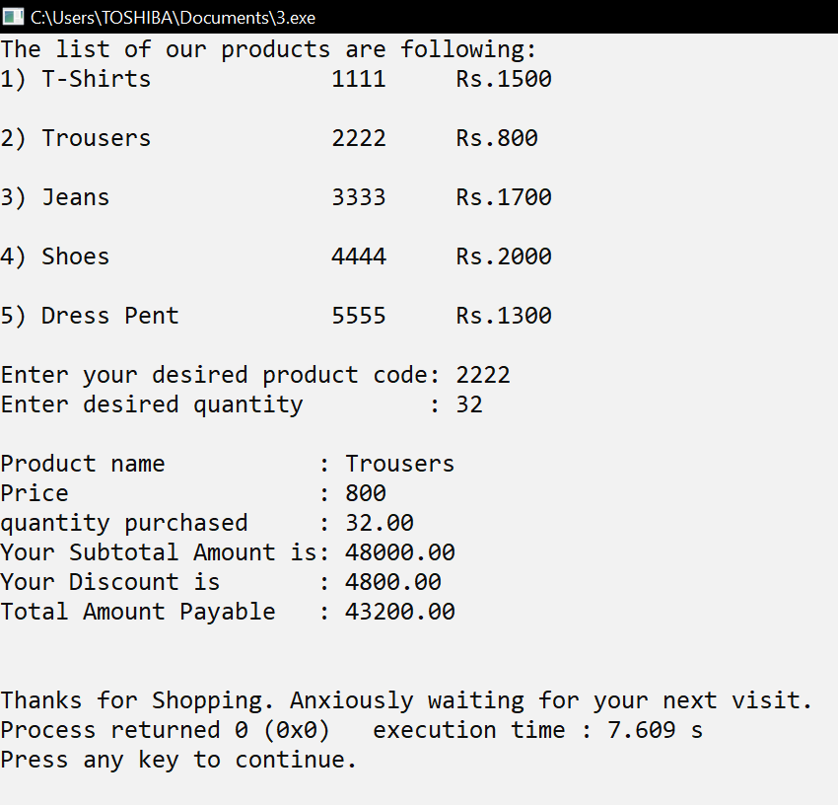

**Flowchart:**

**Begin**

**Total Payable amount**

**Condition if**

**Total Amount >= 10,000**

Discount=10%

Total=Quantity*Rate-(Quantity*Rate*Discount/100)

**Input**

**Product code and Quantity**

**Discount**

**No**

**Yes**

**End**